DATA SCIENCE FINAL ASSIGNMENT – PROJECT REPORT:
INTRODUCTION:
Heart disease remains a major global health concern, leading to millions of deaths annually. The heart_disease.csv dataset is a valuable resource for studying heart-related conditions, containing various medical and lifestyle attributes that influence cardiovascular health.
This dataset typically includes features like age, gender, blood pressure, cholesterol levels, heart rate, and lifestyle factors such as smoking and physical activity. These variables help in understanding risk factors and predicting heart disease.
Healthcare professionals and data scientists use this dataset for predictive modeling, machine learning, and statistical analysis to improve early diagnosis and treatment. By applying data-driven approaches, researchers can identify patterns and develop models that assist in detecting heart disease at an early stage.
The dataset plays a crucial role in medical research, AI-driven diagnostics, and decision-making in healthcare. It helps enhance clinical decision support systems, allowing for more accurate and timely diagnoses.
With increasing advancements in data science and machine learning, analyzing this dataset contributes to better prevention strategies, early interventions, and improved patient outcomes. This makes the heart_disease.csv dataset a critical tool for both research and real-world healthcare applications.

- Data Preprocessing: Data preprocessing is a crucial step in preparing the heart_disease.csv dataset for analysis and machine learning models. It involves cleaning, transforming, and structuring the data to improve model accuracy and performance.

Loading the Dataset

The first step is to load the dataset into a suitable environment, such as Python using the Pandas library. This allows easy manipulation and analysis of data.

Handling Missing Values:

Missing values can affect the accuracy of models. These values can be handled by either removing the incomplete rows or filling them using statistical methods such as mean, median, or mode imputation.

Removing Duplicates:
Duplicate records can lead to bias in predictions. Identifying and removing duplicate entries ensures data integrity.

4.Encoding Categorical Variables.
Some datasets contain categorical data (e.g., Gender: Male/Female). These need to be converted into numerical format using encoding techniques like One-Hot Encoding or Label Encoding.

5.Feature Scaling:

Since different features may have different scales, normalization or standardization techniques are applied to ensure uniformity. This helps machine learning algorithms perform efficiently.

6. Splitting Data for Training and Testing:
To evaluate the model, the dataset is divided into training and testing sets. A common split is 80% training and 20% testing.
These preprocessing steps, the dataset becomes clean, structured, and ready for analysis or predictive modelling.
My project Analysis: “The dataset is clean, without missing values or duplicates. The numerical format of features is suitable for further analysis, and the statistical summary provides insights into feature distributions for additional preprocessing or feature engineering”.
2.Exploratory Data Analysis (EDA): Exploratory Data Analysis (EDA) is a crucial step in understanding the heart_disease.csv dataset. It involves summarizing and visualizing data to uncover patterns, trends, and relationships between variables.
Exploratory Data Analysis (EDA) helps in understanding the heart_disease.csv dataset by identifying patterns, detecting anomalies, and extracting insights for predictive modeling.

1: Dataset Overview:
Examining the number of records, data types, and statistical summaries to understand feature distributions.

2: Handling Missing values:
Identifying and addressing missing data using imputation or removal techniques.

3: Removing Duplicates:
Ensuring data integrity by detecting and eliminating duplicate entries.

4: Data visualisation:
Using histograms, boxplots, and count plots to analyze feature distributions and detect outliers.

5: Categorical Feature Analysis:

Exploring gender, chest pain type, and heart disease presence to detect class imbalances.

5: Correlation Analysis:
Using a correlation matrix to understand relationships between numerical variables.

6: Feature Relationships:
Employing pair plots to identify dependencies and trends between variables.
EDA provides key insights into risk factors, feature relationships, and data quality, improving model performance and predictive accuracy.
My project Analysis: The target variable is nearly balanced, meaning no significant class imbalance. The correlation heatmap identifies important relationships, helping in feature selection and model optimization. Key predictive features include chest pain type, maximum heart rate, ST depression, and exercise-induced angina. These insights will guide further data preprocessing and model building for better heart disease prediction
3.Feature engineering: Feature Engineering is the process of transforming raw data into meaningful features that improve the performance of machine learning models. In the context of the heart disease dataset, it involves selecting, modifying, and creating new features to enhance predictive accuracy.

1. Handling Categorical Variables:
The dataset contains categorical variables such as sex, chest pain type (cp), and resting ECG results (restecg). These variables must be converted into numerical format for machine learning models.
- One-Hot Encoding is used for categorical variables without a natural order (e.g., chest pain type).
- Label Encoding assigns numerical values to ordinal categorical variables (e.g., risk levels).

2.Feature Scaling:
Since numerical variables have different ranges (e.g., cholesterol vs. heart rate), scaling ensures uniformity and prevents bias in models.
- Standardization converts values to a mean of 0 and a standard deviation of 1.
- Normalization scales values between 0 and 1, making them suitable for algorithms like k-NN.

3.Feature Selection:
Not all features contribute equally to prediction, and irrelevant features can reduce accuracy.
- Correlation Analysis helps identify and remove highly correlated features to prevent redundancy.
- Recursive Feature Elimination (RFE) ranks features based on their importance in prediction.

4.Creating New Features:
Generating new features from existing data enhances model performance.
- Age Grouping converts continuous age values into categories (e.g., Young, Middle-aged, Elderly).
- Risk Score Calculation combines multiple health indicators (e.g., cholesterol, blood pressure) into a single predictive score.
- Body Mass Index (BMI) can be derived if height and weight data are available.

5. Handling Outliers
Extreme values can distort predictions and need to be addressed using:
- Boxplots and histograms to visualize anomalies.
- Interquartile Range (IQR) or Z-score methods to detect and remove outliers.
Feature engineering is essential for improving the quality and interpretability of data. By refining categorical variables, scaling numerical values, selecting relevant features, and creating new attributes, models become more efficient and accurate in predicting heart disease.
My project Analysis: The feature engineering step has successfully transformed the dataset by selecting relevant features and scaling numerical data. This ensures better model learning and improved performance in predicting heart disease.
4.MODEL DEVELOPMENT:
- The Random Forest Classifier is a powerful and versatile model for classification tasks like heart disease prediction.
- It combines multiple decision trees to improve accuracy and reduce overfitting.
- The model provides high accuracy, is robust to noise, and handles feature importance well.
- However, it can be computationally expensive with a large number of trees.
By tuning hyperparameters, the model can be further optimized for better performance.
5.EVALUATION:
1. Accuracy:
- The model achieved an accuracy of 87% (0.87), meaning that 87% of the total predictions were correct.
- Accuracy is a useful metric when the dataset is balanced (i.e., similar counts of positive and negative cases.
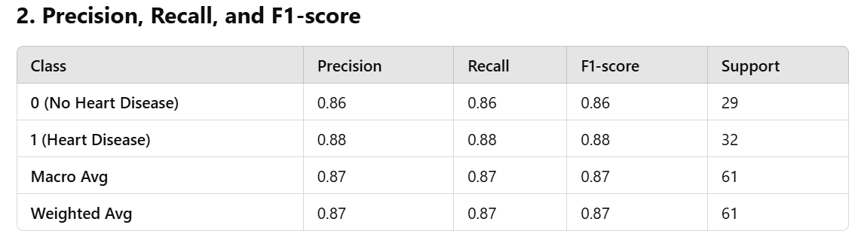
Precision
- Precision measures how many of the predicted positive cases (heart disease) were actually correct.
- Class 1 (Heart Disease): Precision = 0.88 → 88% of predicted heart disease cases were actually correct.
- Class 0 (No Disease): Precision = 0.86 → 86% of predicted “no disease” cases were correct.
Recall (Sensitivity or True Positive Rate)
- Recall tells us how many of the actual positive cases (patients with heart disease) were correctly identified.
- Class 1 (Heart Disease): Recall = 0.88 → 88% of actual heart disease cases were correctly detected.
- Class 0 (No Disease): Recall = 0.86 → 86% of people who actually didn’t have heart disease were correctly classified.
F1-score
- F1-score is the harmonic mean of precision and recall, providing a balanced measure.
- The F1-score for both classes is high (0.86 - 0.88), meaning that the model balances false positives and false negatives well.
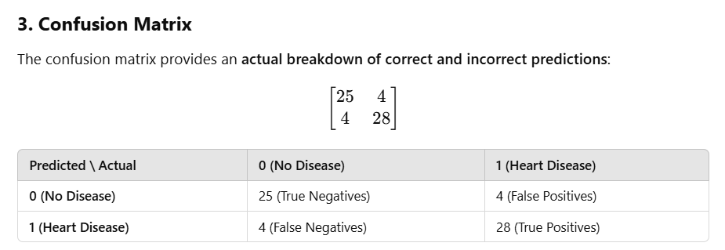
• True Positives (TP = 28) → Model correctly predicted 28 cases of heart disease.
• True Negatives (TN = 25) → Model correctly predicted 25 cases of no disease.
• False Positives (FP = 4) → Model incorrectly predicted 4 people have heart disease when they do not (false alarms).
• False Negatives (FN = 4) → Model incorrectly predicted 4 people as "no disease" when they actually have it (missed cases).
✅ High Performance: The model performs well with an 87% accuracy and strong precision, recall, and F1-scores.
✅ Balanced Predictions: The model correctly identifies both patients with and without heart disease with minimal errors.
✅ Low False Negatives (FN = 4): Missing only 4 cases is crucial in medical predictions, as false negatives can be dangerous.
✅ Low False Positives (FP = 4): False positives lead to unnecessary medical tests, but this number is relatively low.
The Random Forest Classifier successfully predicts heart disease with high accuracy (87%) and balanced performance metrics. The low number of false negatives (4) is particularly important in medical predictions, as missing actual heart disease cases can be risky.
Feature importance helps in understanding which factors contribute most to the model's decision-making process. In this case, the Random Forest Classifier assigns different importance scores to various features used for heart disease prediction.

